# INTRODUCTION

## 1.1 OVERVIEW

The LOK SABHA comprises of a total of 545 seats. Out of these, elections will be conducted by the Election Commission to fill 543 seats. The remaining two seats are filled by nomination of representatives of the Anglo-Indian Community if the President feels that this community has not been represented adequately.

## 1.2 PURPOSE

General elections were held in India in seven phases from 11 April to May 2019 to elect the members of the 17th LOK SABHA. Votes were counted and the result was declared on 23 May. The election resulted in a landslide victory from the BJP which won 303 seats and formed the government. BJIP’s sitting MP from NAVSARI CR PATIL, who was seeking re-election from the seat, registered the highest victory margin in the 2019 LOK SABHA elections. He defeated his nearest congress rival DB PATIL by a record 6.89 lakh votes.

The BJP received 37l36% of vote, National Democratic Alliance received 45% of vote Indian National Congress won 10% of vote United Progressive Alliance won 91 seats, while other parties won 98 states.

PROBLEM DEFINITION & DESIGN THINKING

## 2.1 Empathy Map

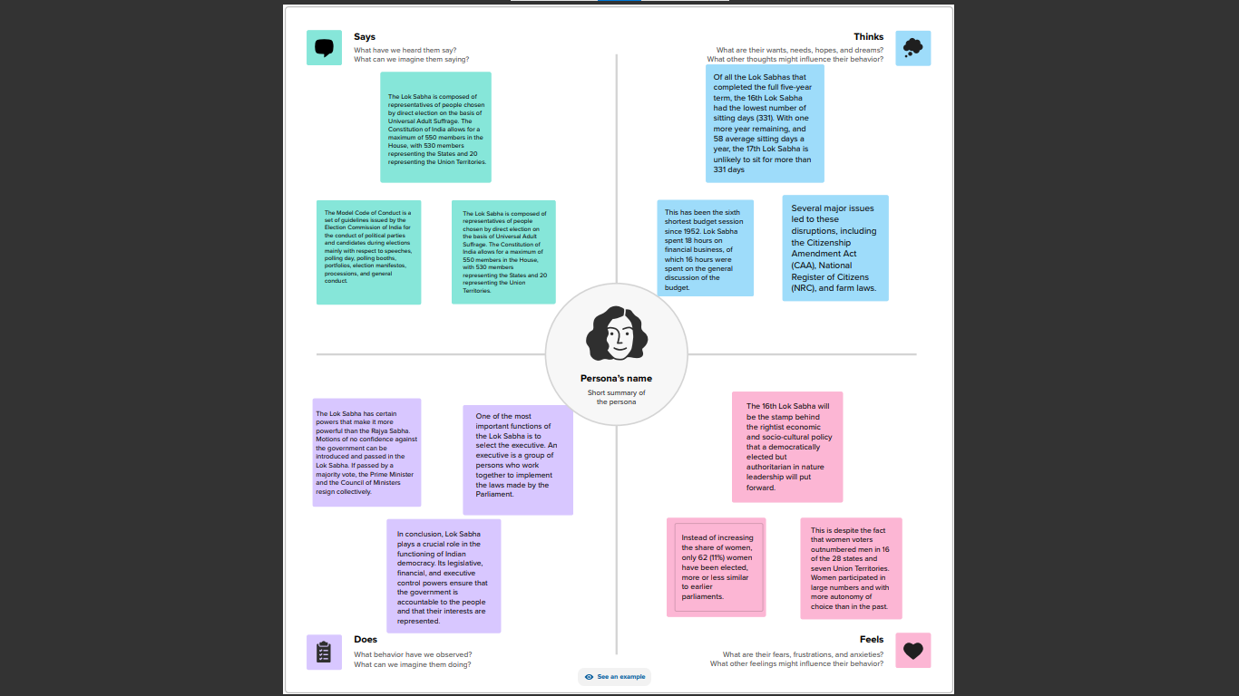

## 2.2 Ideation & Brainstorming Map

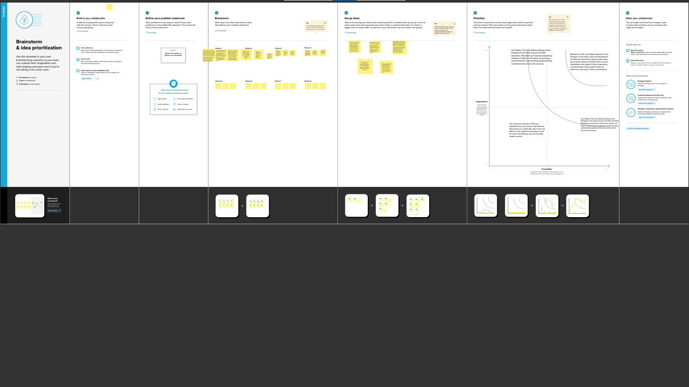

RESULT

## 3.1 Dashboard & Story

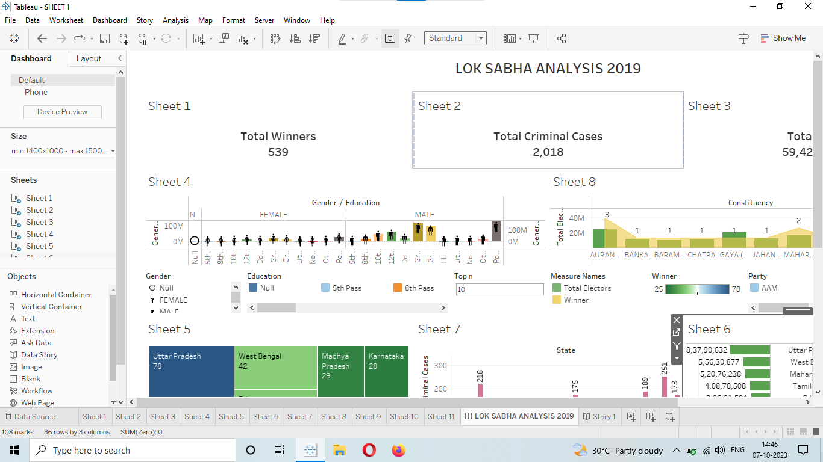

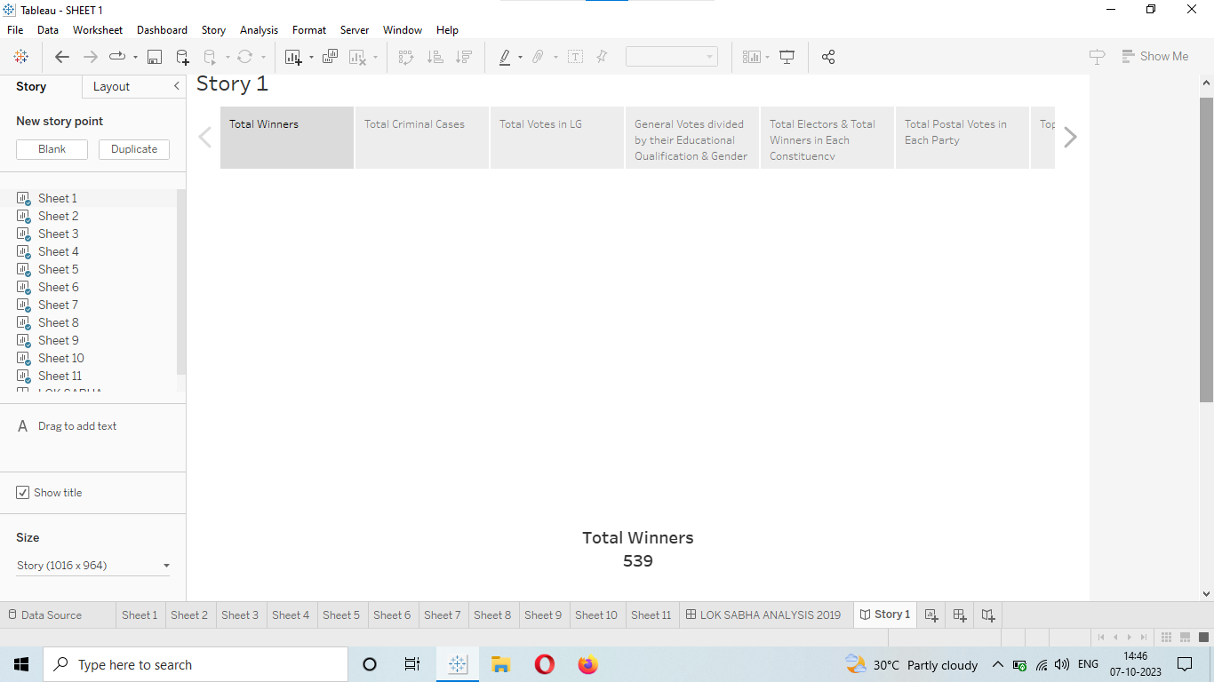

# ADVANTAGES AND DISADVANTAGES

People of India directly choose the member of LOK SABHA so this house is direct representation of people. Any central government need simple majority to form a government. If motion of no confidence passed by this house the prime minister and his cabinet need to resign immediately.

1-frequent disruption in the working of the LOK SABHA either due to opposition or due to government.

2-many MPs are incomplete to raise the issues concerning the people.

3-lack of time in terms of no. session of the parliament.

APPLICATIONS

The house meets in the LOK SABHA Chambers of the Parliament House, New Delhi. There are more other functions of the LOK SABHA like redressal of grievances, judicial functions, and miscellaneous functions. LOK SABHA members have a tenure of 5 years, after which assembly and the members dissolve to have a fresh election.

CONCLUSION

The LOK SABHA has certain powers that make it more powerful than the RAJYA SABHA. Motions of no confidence against the government can be introduced and passed in the LOK SABHA. If passed by a majority vote, the Prime Minister and the Council of Ministers resign collectively

.

FUTURE SCOPE

The power of moving confidence motion against an elected government and sanctioning financial power make LOK SABHA than RAJYA SABHA. The President of India, the LOK SABHA, and the RAJYA SABHA are collectively known as the Indian Parliament, which is the chief legislative authority in India. There is proposal to increase strength claims congress leader.